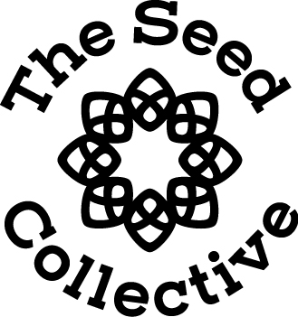

The Holistic Birth and Parenting Collective
Manifesto of Service

“ Providing complete nourishment, support and empowerment throughout your pregnancy birth and postpartum period”

Our offering has been designed with you in mind. To provide a service that covers all areas of your journey with a unified approach to your wellbeing.

Frist and foremost we want you to know that this is your experience and we are honored to be apart of it. So thank you from the bottom of our hearts.

We acknowledge that birth is a right of passage as parents. That this life changing process of bringing forth new life comes with many challenges. With that said we will offer our expertise, love and unconditional support. In the case that something maybe outside of our area of expertise we will refer you to who we feel is the best practitioner for you.

Being birth workers is not a job it is our calling. We put our heart and soul into preparing our unique offerings for you.
In doing so we promise to:
Listen and hear what your core desires and intentions are and will do our best to help you achieve them.
Lead the way in providing you with conscious parenting tools to support you, your relationship and your new baby.
Have a unified approach to your wellbeing during our time together and will work as a collective to help you reach your goals.
Hold the space for you to explore what feels best for you and will provide you with the tools and resources to make informed choices.

During our time together we will practice courage by showing up. Showing up to share the challenges you are facing as well as the joy you are experiencing – all of it.

We will meet you where you are at and will encourage you to take ownership of your journey for at the end of our time together it is your experience. We will provide you with the support to feel:
Empowered
Nurtured
Safe
Powerful
Knowledgeable
Prepared
Confident
Worthy and
Loved
We believe this model of care will hold you throughout your journey to ensure you are prepared on every level to move into this next exciting chapter of your life.

